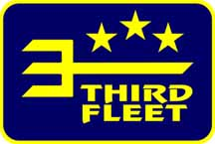 | 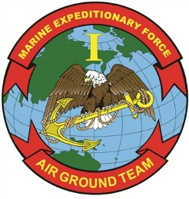
Public Affairs Office  Commander, U.S. Third Fleet  Phone: (619) 767- 4387 | I Marine Expeditionary Force  Public Affairs Office  Phone: (760) 763-7047
U.S. Navy and Marine Corps, partner nations to participate in amphibious exercise

By Third Fleet and I Marine Expeditionary Force Public Affairs

SAN DIEGO – Naval and ground forces from the United States, Canada, Japan and New Zealand will participate in amphibious exercise Dawn Blitz 2013 off the coast of Southern California June 11-28.

Dawn Blitz 2013 is a scenario-driven exercise designed to train the Navy and Marine Corps in operations expected of an amphibious task force. The exercise will test staffs in the planning and execution of amphibious operations in a series of live training events.

Units from U.S. Third Fleet and I Marine Expeditionary Force will utilize the latest technologies and live exercises to accomplish Dawn Blitz 2013 training objectives. The exercise will involve an amphibious assault, mine operations, live-fire opportunities, and Maritime Prepositioning Force (MPF) training and seabasing operations.

This exercise is one of a series of amphibious training events on both coasts of the U.S. that take place annually. Exercises like Dawn Blitz 2013 provide realistic, relevant training necessary for effective global crisis response expected of the Navy and Marine Corps.

Media interested in covering the exercise should contact U.S. Third Fleet Public Affairs at (619) 767-4387 or I MEF public affairs at (760) 763-7047 or imefpublicaffairs@usmc.mil.

U.S. Third Fleet leads naval forces in the Eastern Pacific from the West Coast of North America to the International Date Line and provides realistic, relevant training necessary for an effective global Navy.

When directed, I MEF deploys and is employed as a Marine Air Ground Task Force (MAGTF) in support of Combatant Commander (COCOM) requirements for contingency response or Major Theater War; with appropriate augmentation, serves as the core element of a Joint Task Force (JTF); prepares and deploys combat ready MAGTF’s to support COCOM presence and crisis response; and supports service and COCOM initiatives as required.

-- 30 –

1st Lt. Garth Langley, public affairs officer, 1st Marine Expeditionary Brigade
(760) 763-7047, garth.langley@usmc.mil,
www.facebook.com/1stMarineExpeditionaryBrigade

