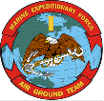
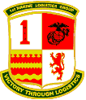
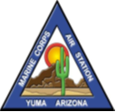
FY 2015
West Coast
Equal Opportunity Training
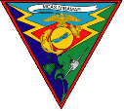
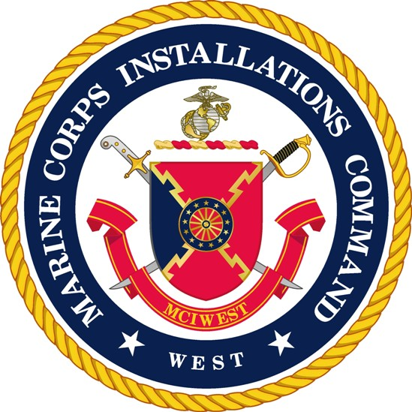

Equal Opportunity Representative Course (EORC)

Date Class# Course Administrator
Oct 27 – 31 01 – 15 I MLG Camp Pend
Jan 12-16 02 – 15 MCRD San Diego
Mar 23-27 03 – 15 MCI West, Camp Pend
Jun 8-12 04 – 15 Miramar
Aug 17-21 05 – 15 1st Mar DIV

Senior Leaders Workshop (SLW)
Feb 3-5 01 – 15 3rd MAW
May 12-14 02 – 15 I MEF Camp Pend
Sep 15-17 03 – 15 MCRD San Diego

Equal Opportunity Representative (EOR) Quarterly Sustainment Training

Oct, Nov, or Dec 14 Per command EOA
Jan, Feb, or Mar 15 Per command EOA
Apr, May, or Jun 15 Per command EOA
Jul, Aug, or Sep 15 Per command EOA

NOTES:
1. EORC training consists of 40 consecutive hours of in-depth review of all EO elements and thoroughly prepares the EOR/CEOM to effectively manage their command’s program.
2. The Senior Leaders, SNCO, and NCO Workshops are designed to stress how EO issues impact unit cohesion, mission accomplishment, and combat readiness. These workshops have been established to assist commands in being proactive with EO issues and concerns that arise, and to assist the immediate chain of command with the necessary information to resolve EO issues at the lowest level possible
3. “Space is Limited” per course. Contact your respective EO Advisor listed below to reserve a seat @ DSN:

MCI West 365-5742 MCAS Miramar 267-1269 MCAS Yuma 269-2529

MCAGCC 29 Palms 230-4567 MCRD San Diego 524-8730 I MEF 365-9167

3d MAW 267-7447 1st Mar Div 365-0484 1st MLG 365-5117

Reference: MCO P5354.1D w/ch 1

